**2022 SPCP Conference Website**

**I would like the information in the menu bar to be in the same order as the one on the plan your stay page.**

**Plan your stay**

**I WOULD LIKE TO ADD A BANNER WITH THESE PICTURES:**

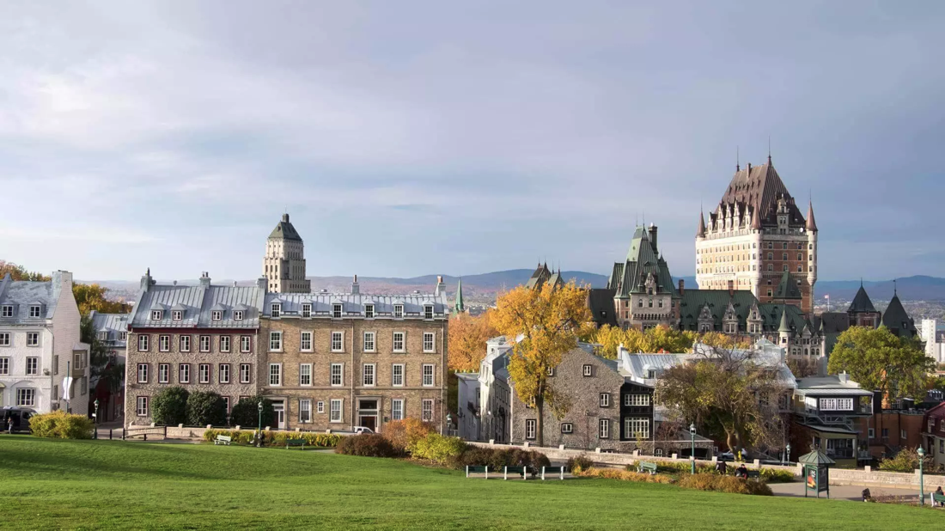

Name: dscf0483web

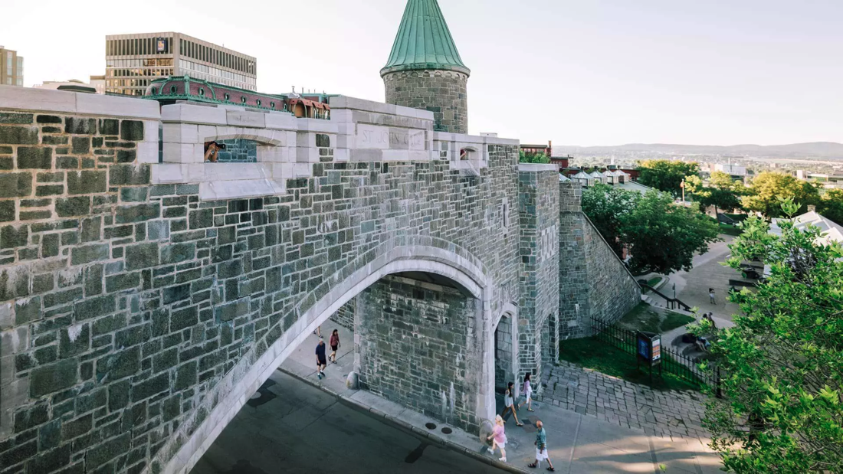

Name: fortifications_jeff-frenette-photography_2016-19aout-1764_opt

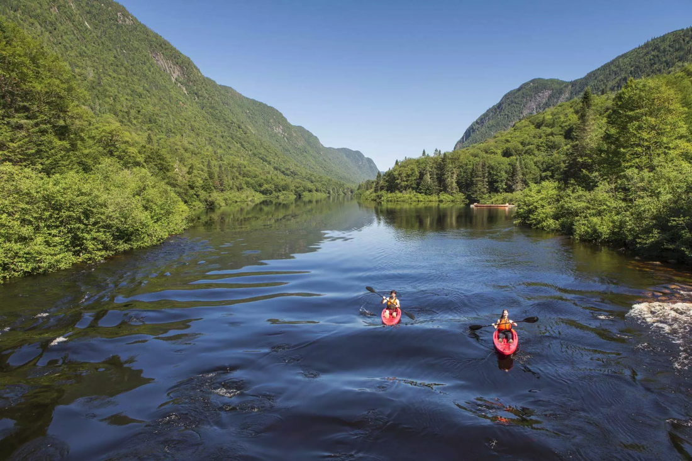

Name: jac_150729_0045_Mathieu-Dupuis_088D8604-F593-4A40-B890AE170D24DF27_67459975-e565-4460-8670773a0233f8e4

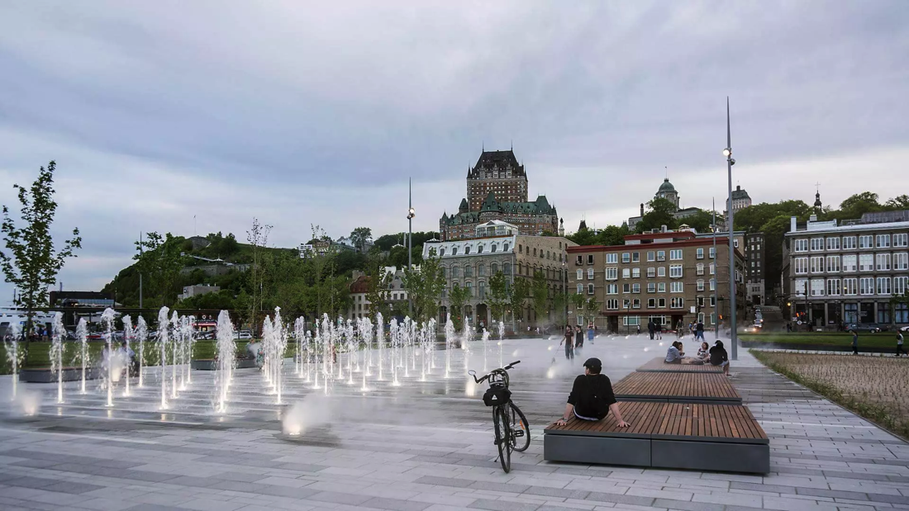

Name: 35070396942_35e65e4513_o_0

**In and Around Quebec City**

From spas to adventures in the wood to city tours, Quebec has a lot to offer. Here’s a variety of activities you'll get the chance to enjoy during your stay.

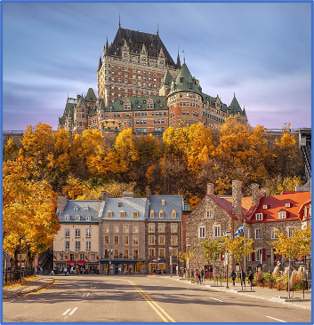Name: castle

**Eat and Sleep**

Discover the restaurants and local artisans promising you an extraordinary culinary experience as well as the wide variety of hotels and accommodation options.

Keeping the current picture

**Sanitary Measures – Covid 19**

Travel Restrictions and Covid-19 Update.

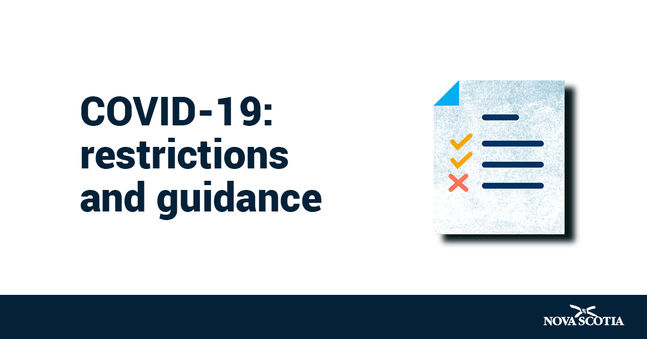

Name: restrictions-and-guidance-en

If you can cut the Nova Scotia thing at the bottom it would be nice. It can also be only the text.

**Travel Authorizations**

All travelers must present acceptable travel documents and identification must be presented at the border. We strongly suggest that you begin the process as soon as possible to avoid delays.



Name: luggage

You can put the suitcase only.

**In and around Quebec City**

**One picture banner:**

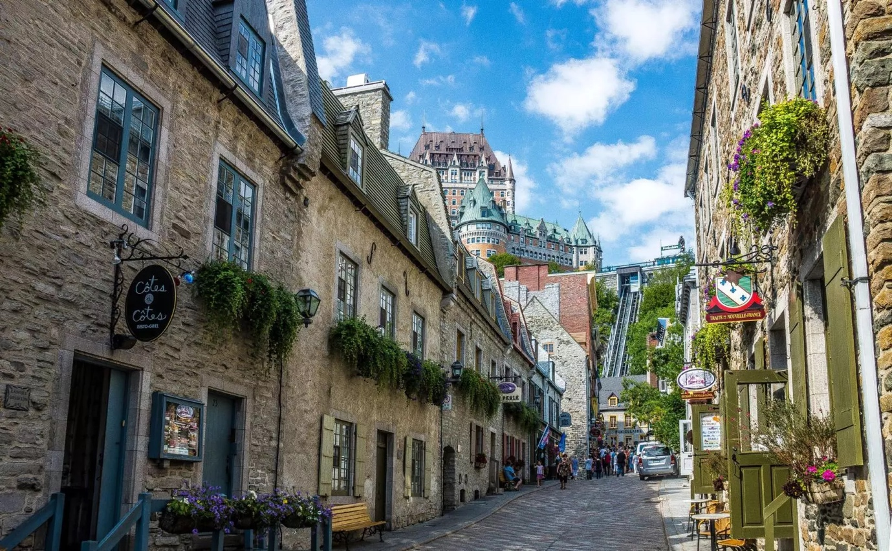

**Name: AV_26et27aout2014 022_COR_S**

**In Quebec City:**

1. **Explore the City: You'll find 400 years of history and a thousand and one things to experience.**

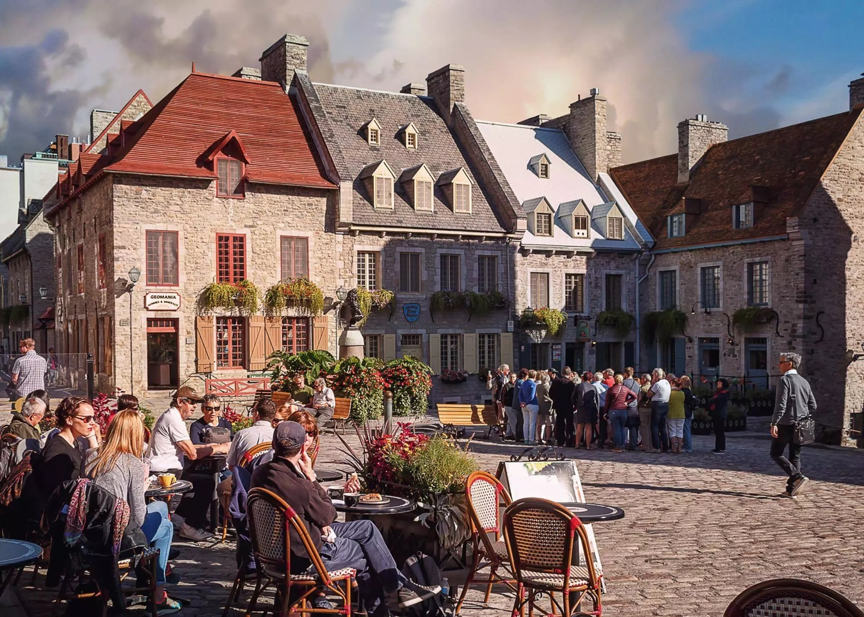

Name: Summer-will-fight-till-the-end

* Guided tours
  + [Old Québec Bus Tours](https://www.toursvieuxquebec.com/en/forfait/Quebec-city-tour-by-bus)
  + [Guided Walking Tours of Old Québec City](https://www.quebec-cite.com/en/what-to-do-quebec-city/walking-tours)
  + [Walking Food Tours in Old Québec](https://www.quebec-cite.com/en/what-to-do-quebec-city/food-tours)

Banner with these pictures:

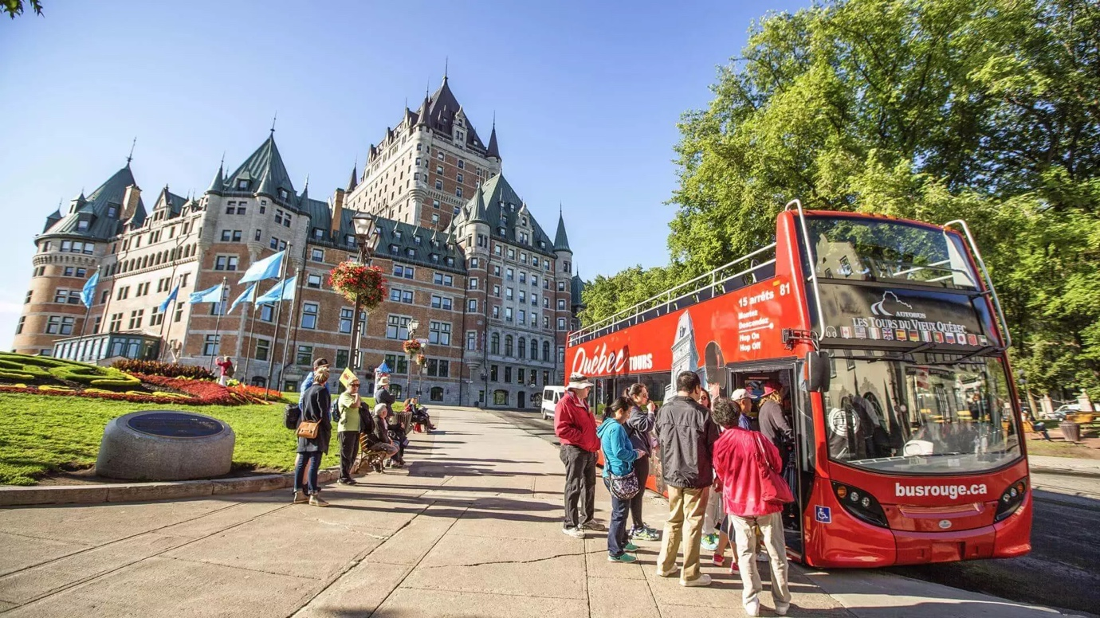

Name: otqete_160823_49a0193

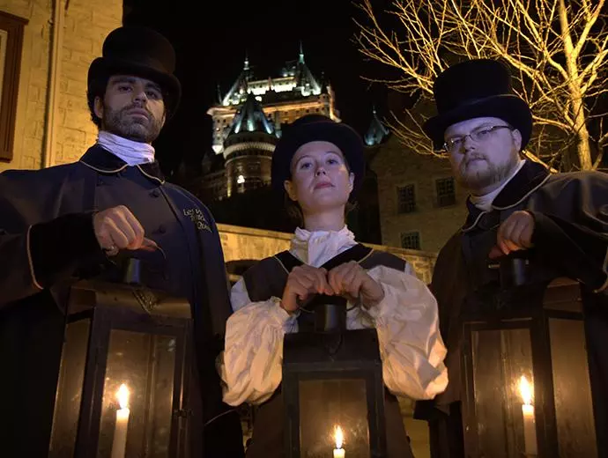

Name: photo-lesvisitesfantomesdequebec-030-05531e3d5056a36_05531f6a-5056-a36a-07dff1e50fb958d0

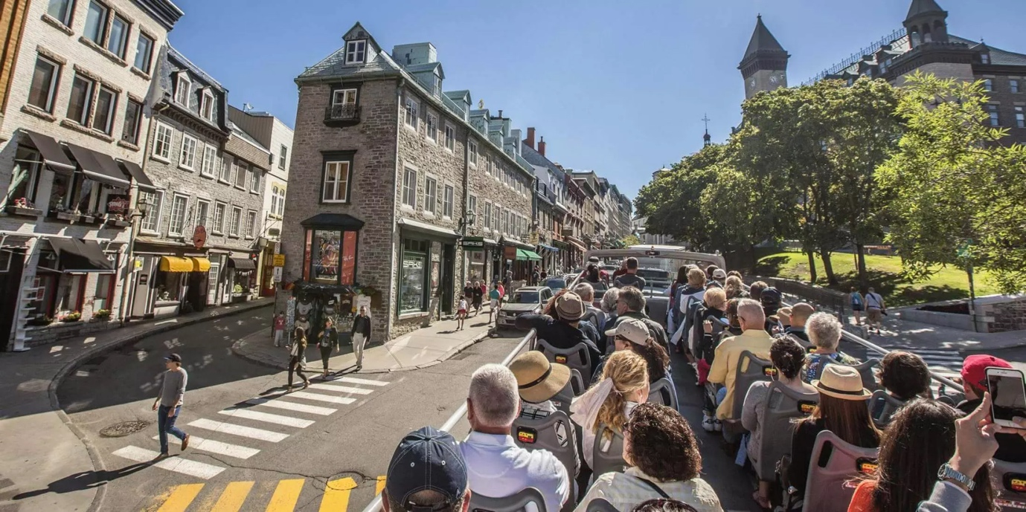

Name: lyraphoto_160823_49a0821_cor

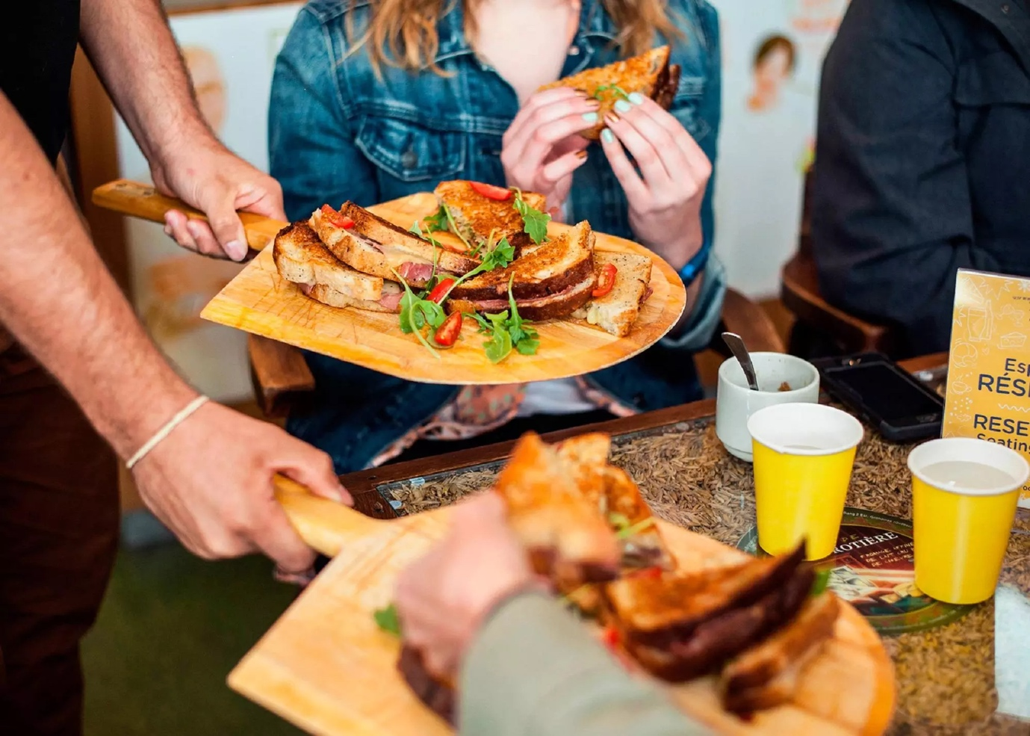

Name: Visites gourmandes de Quebec

* Walking and Treck
  + [Parc de la Chute-Montmorency](https://www.sepaq.com/destinations/parc-chute-montmorency/quoi-faire/sentiers-marche-randonnee.dot?language_id=1)
  + [Quartier du Petit-Champlain](https://www.quartierpetitchamplain.com/en/)
  + [Domaine des Maizerets Regional Park](https://www.domainemaizerets.com/)
  + [Bois-de-Coulonge Park](https://www.capitale.gouv.qc.ca/sites-de-la-capitale/parcs/parc-du-bois-de-coulonge/)
  + [Linear Park of the River Saint-Charles](https://societerivierestcharles.qc.ca/)
  + [And more…](https://www.quebec-cite.com/en/what-to-do-quebec-city/nature-walk-gardens)

Banner with these pictures:

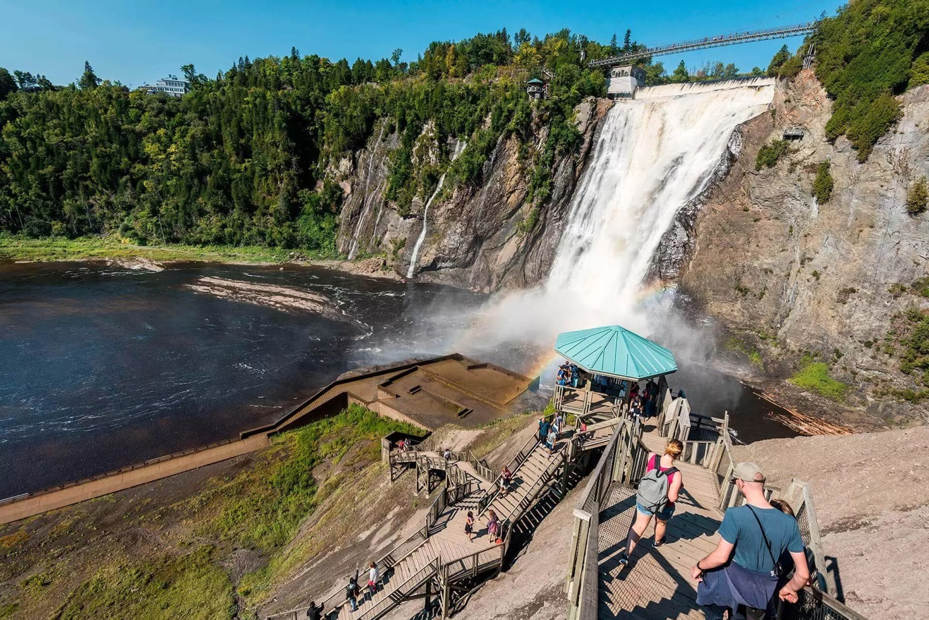

Name : jefffrenettephotography_otqete_160913_0090

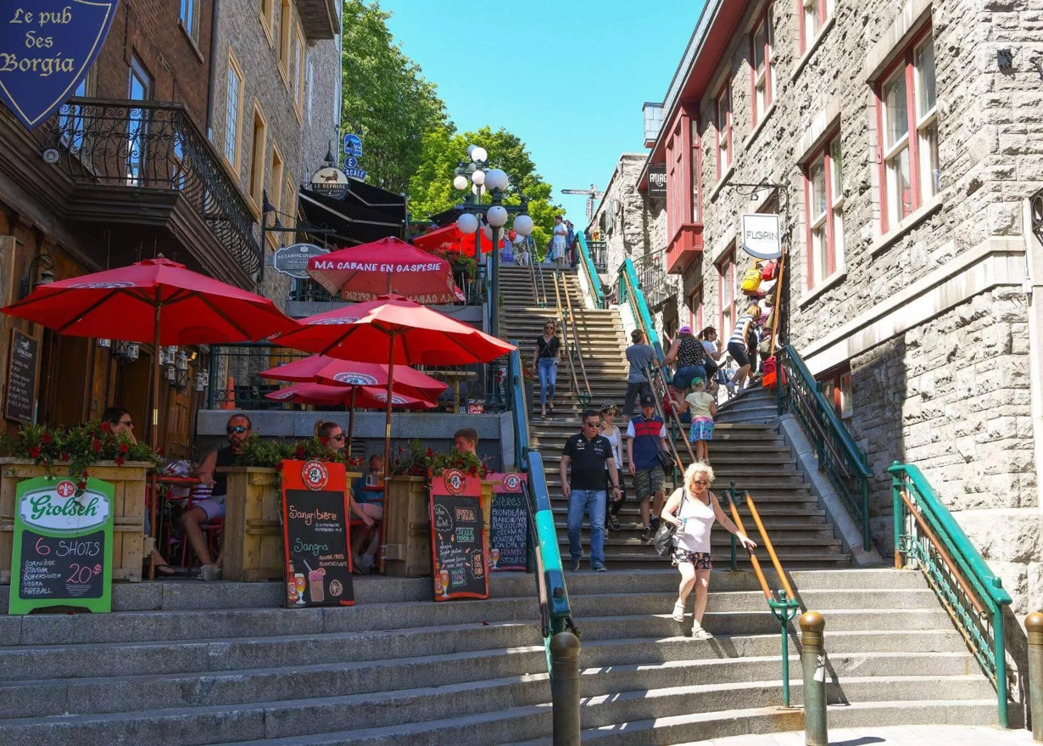

Name : DSC_6132_1

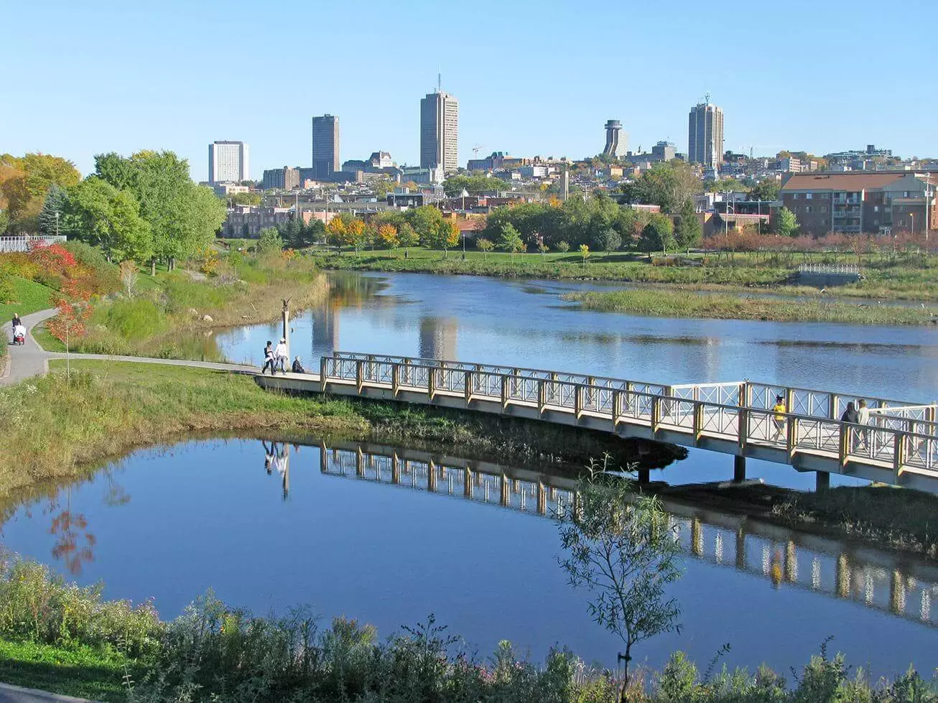

Name : st-charles

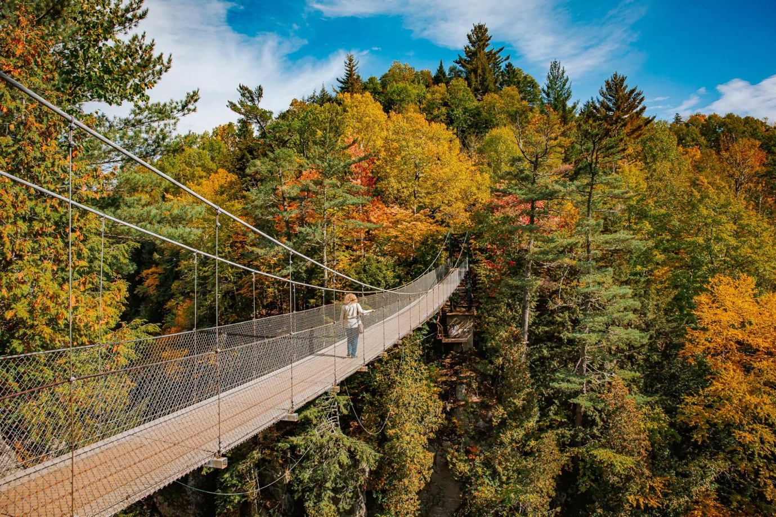

Name : web_automne_2019_otq_audetphoto-144

1. Wellness activities: There is nothing like spending a day at the spa to recover from a 3-day conference

* [SKYSPA Quebec City](https://www.skyspa.ca/en/quebec)
* [Moment Spa Le Château Frontenac](https://momentspa.ca/en/spas/le_chateau_frontenac)
* [Strøm Nordic Spa Old Quebec](https://www.stromspa.com/vieux-quebec/en/)

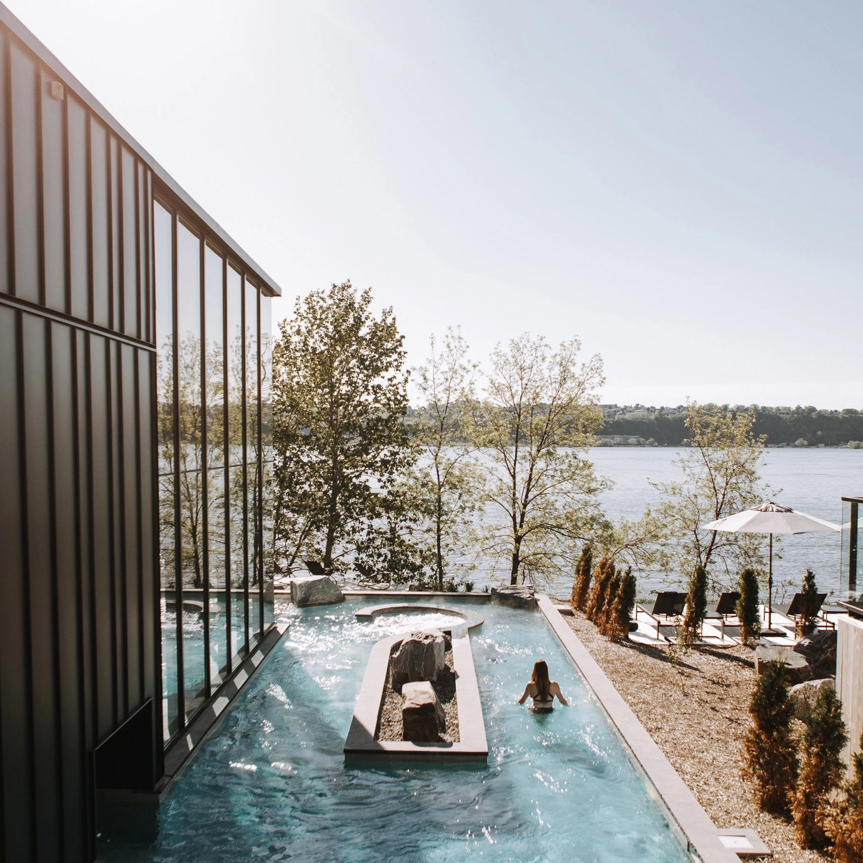

Name: strom-nordic-spa-old-quebec-lemay-michaud-architecture-quebec-city-canada_dezeen_2364_sq2

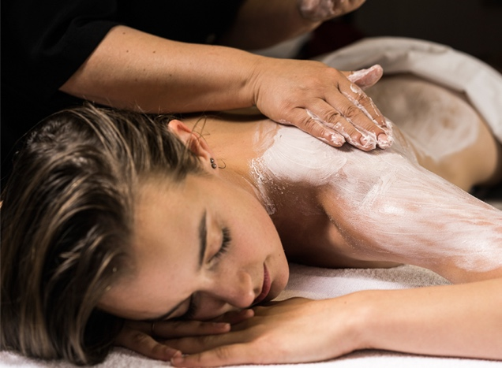

Name: enveloppement_3

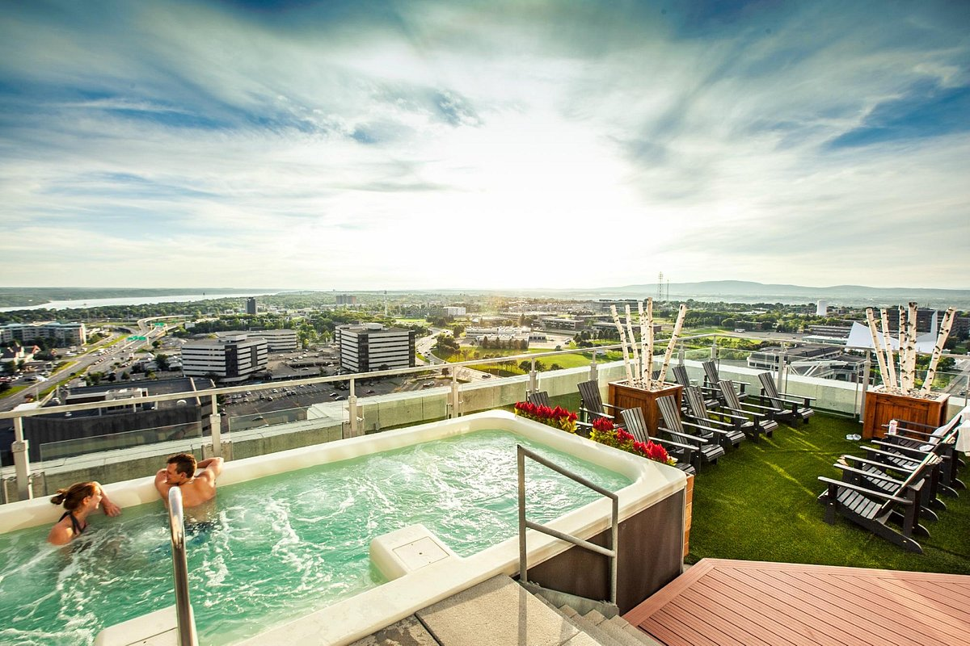

Name: sky-spa

1. Visit Historic Sites

As a UNESCO World Heritage site, Old Québec is full of history. See how the French, British, First Nations, and North Americans have left their mark over the past 400 years.

* + [Citadelle of Québec](https://www.lacitadelle.qc.ca/en/)
  + [Plains of Abraham](https://www.ccbn-nbc.gc.ca/en/)
  + [Fortifications of Québec National Historic Site](https://www.pc.gc.ca/en/lhn-nhs/qc/fortifications?utm_source=quebec-cite.com&utm_medium=affiliate&utm_campaign=OTQ&utm_content=web)
  + [Château Frontenac](https://www.quebec-cite.com/en/what-to-do-quebec-city/tour-chateau-frontenac)
  + [Saint-Louis Forts and Châteaux National Historic Site](https://www.pc.gc.ca/en/lhn-nhs/qc/saintlouisforts)
  + [Parliament Building](http://www.assnat.qc.ca/en/index.html?utm_source=quebec-cite.com&utm_medium=affiliate&utm_campaign=OTQ&utm_content=web)
  + [Morrin Centre](https://www.morrin.org/en/)
  + [Monastère des Augustines](https://monastere.ca/en)

1. Visit Museums
   * [Musée National des Beaux-Arts du Québec](https://www.mnbaq.org/en)
   * [Musée de la Civilisation](https://www.mcq.org/en/)
   * [Hôtel-Musée Premières Nations](https://www.hotelpremieresnations.ca/en/)
   * [Musée du Fort – Interpretation Centres](https://www.museedufort.com/en/?utm_source=quebec-cite.com&utm_medium=affiliate&utm_campaign=OTQ&utm_content=web)
   * [Musée Royal 22e Régiment](http://www.lacitadelle.qc.ca/en/the-museum/its-mission.html)
   * [Musée huron-wendat](https://museehuronwendat.ca/en/)
   * [Naval Museum of Québec](https://www.canada.ca/en/services/defence/caf/militaryhistory/militarymuseums/museums/military-museums-directory/naval-museum-quebec.html?utm_source=quebec-cite.com&utm_medium=affiliate&utm_campaign=OTQ&utm_content=web)
   * [Aquarium du Québec](ohttps://www.sepaq.com/en/reservation/purchase/aquarium-du-quebec-ticket?utm_source=quebec-cite.com&utm_medium=affiliate&utm_campaign=OTQ&utm_content=web)

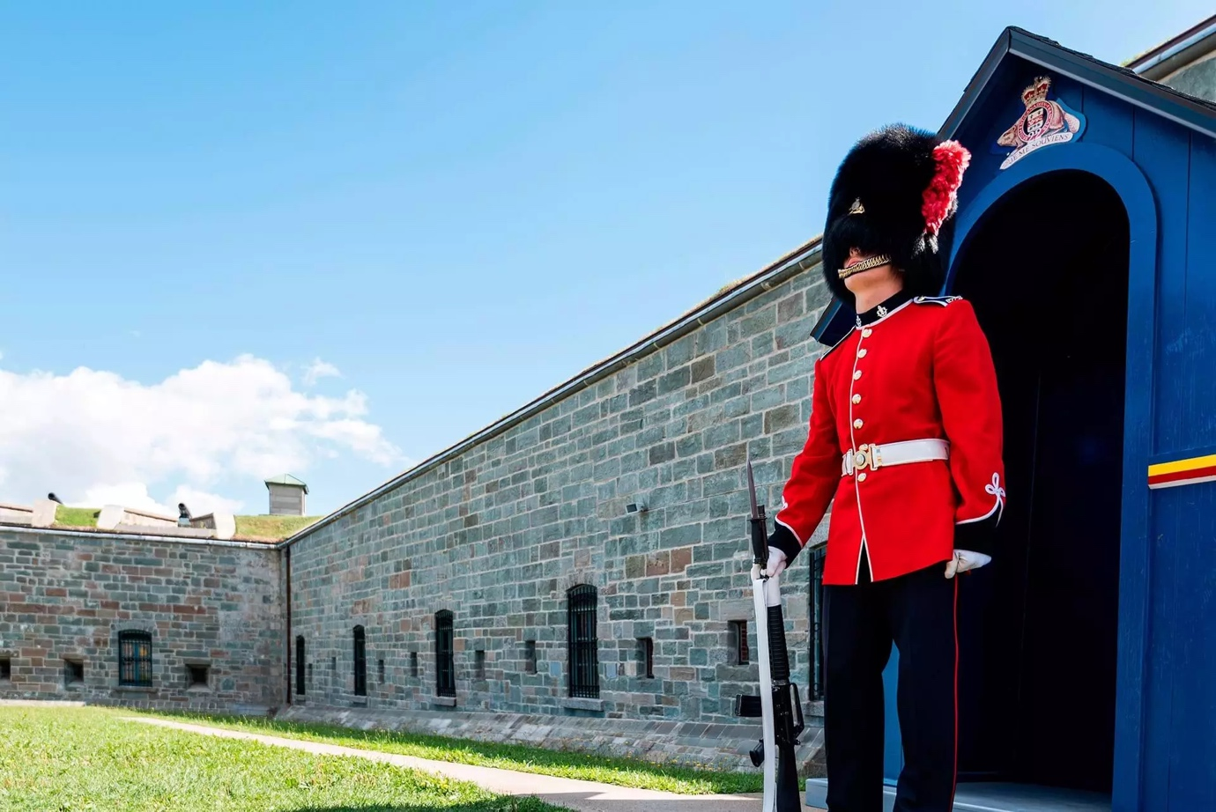

Name: citadelle

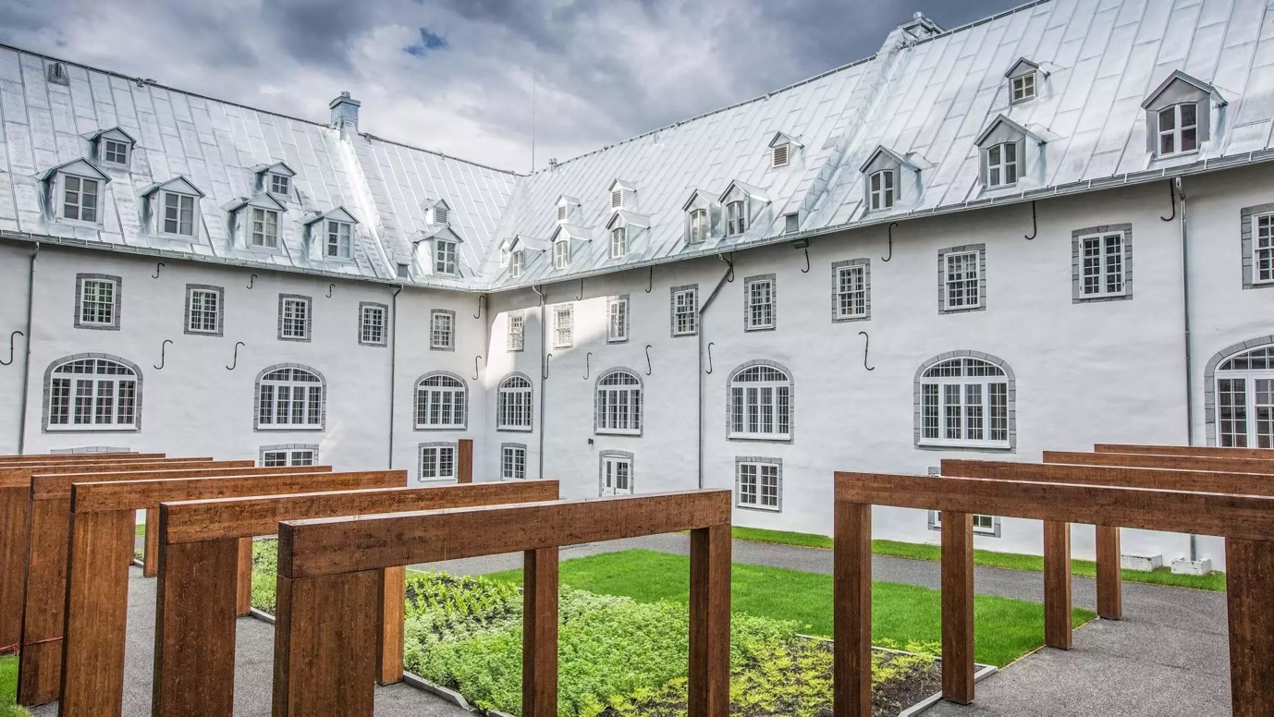

Name: lemonasteredesaugustines_cour

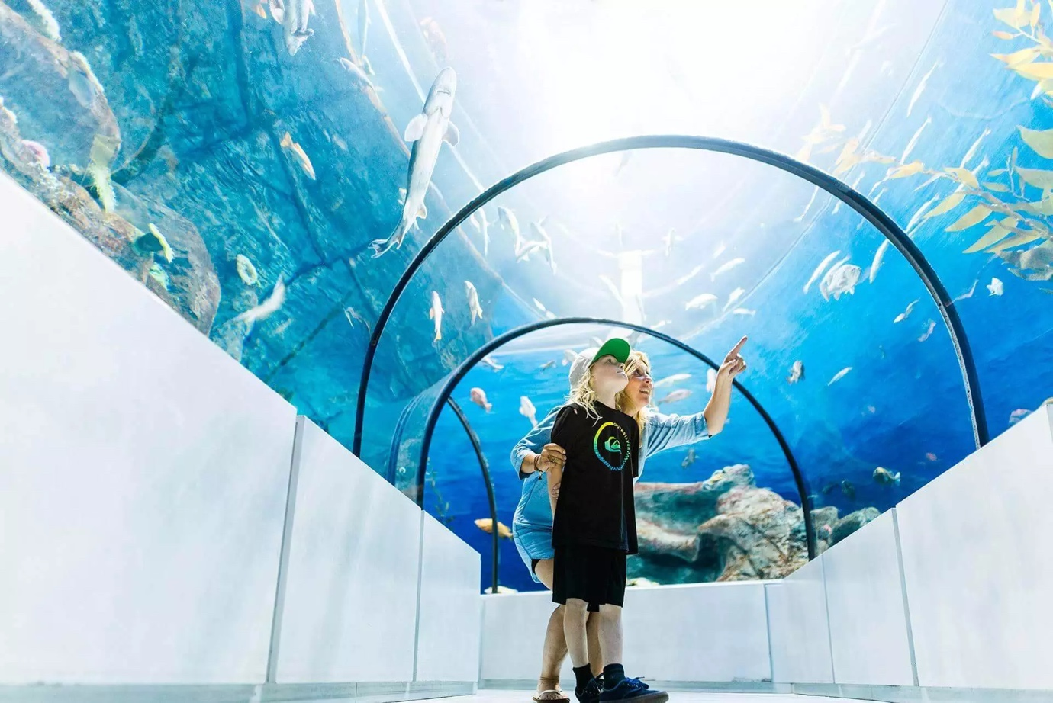

Name: jefffrenettephotography_otq-ete2016-13sept-1870-edit

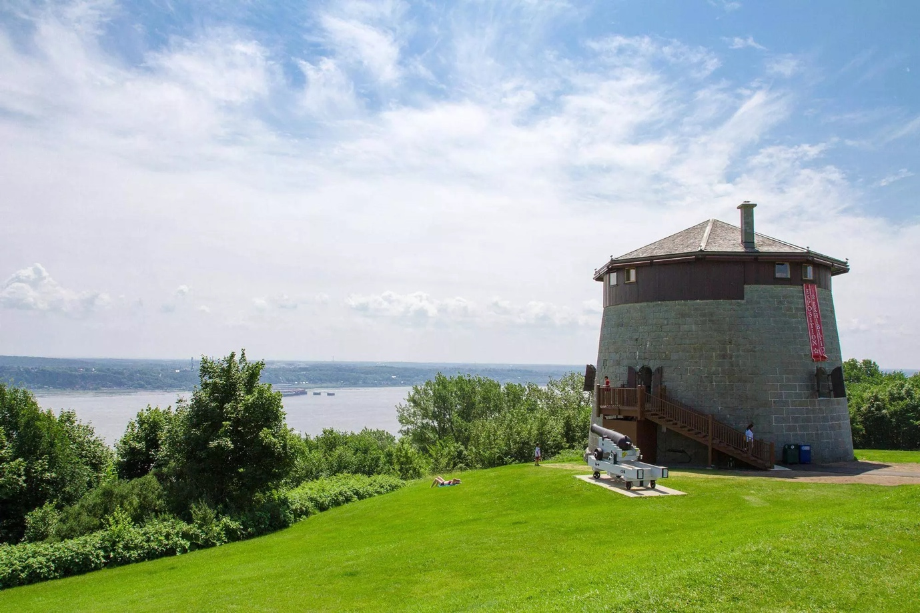

Name: plaines

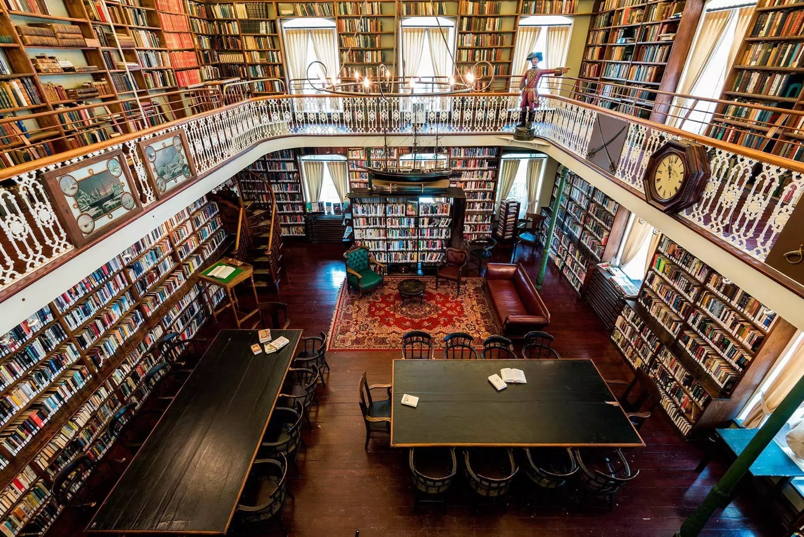

Name: jefffrenettephotography_otqete_160830_0038

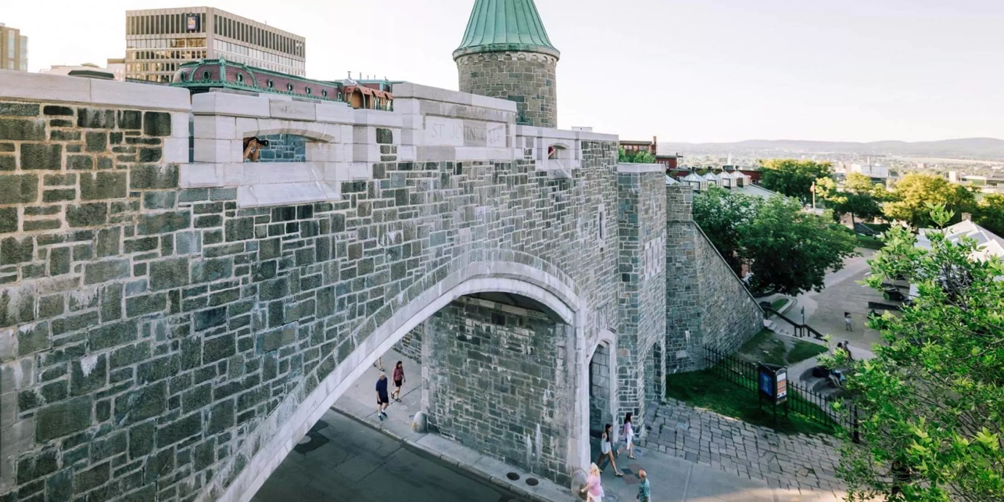

Name: fortifications_jeff-frenette-photography_2016-19aout-1764_opt0-d156e2fd5056a36_d156e43b-5056-a36a-078f97dbfc021f81

1. **Night life**

* Pubs:
* [Restaurant/Pub D’Orsay](https://www.dorsayrestaurant.com/) $$
* Pub Nelligan’s – Irish Pub $$
* [Jack Saloon](http://jacksaloon.com/en/our-restaurants/) $$
* [Galway Irish Pub](https://www.pubgalway.com/?lang=en) $$
* [Pub du Parvis](https://pubduparvis.ca/en/) $$
* [Taverne Jos Dion](https://www.facebook.com/tavernejosdion/?ref=page_internal) $
* [Taverne Grande Allée](https://www.tavernegrandeallee.com/?lang=en) $$
* Live Music
  + Bistrot Le [Pape Georges – Live music](https://www.facebook.com/papegeorges/) $$
  + [District Saint-Joseph](https://www.districtstjoseph.ca/District-Saint-Joseph/District-Saint-Joseph) $$
  + [Les Voûtes de Napoléon – Live](http://voutesdenapoleon.com/) music $$
  + [La Piazz Grande-Allée – Live](https://www.lapiazz.ca/) music $$
  + [London Jack – English Pub](https://londonjack.ca/) $$
  + [Les Yeux Bleux Bar](https://www.facebook.com/Barlesyeuxbleus/?ref=page_internal) $$
  + [Murphy’s Irish Pub](https://en.chezmurphys.com/programmation) $$
  + [St-Patrick Irish Pub](https://pubsaintpatrick.ca/home/) $$
  + [Saint-Alexandre Pub](https://en.pubstalexandre.com/programmation) $$
  + [Bar Ste-Angele – Jazz night](https://www.facebook.com/BarSainteAngele/?locale2=fr_CA) $$

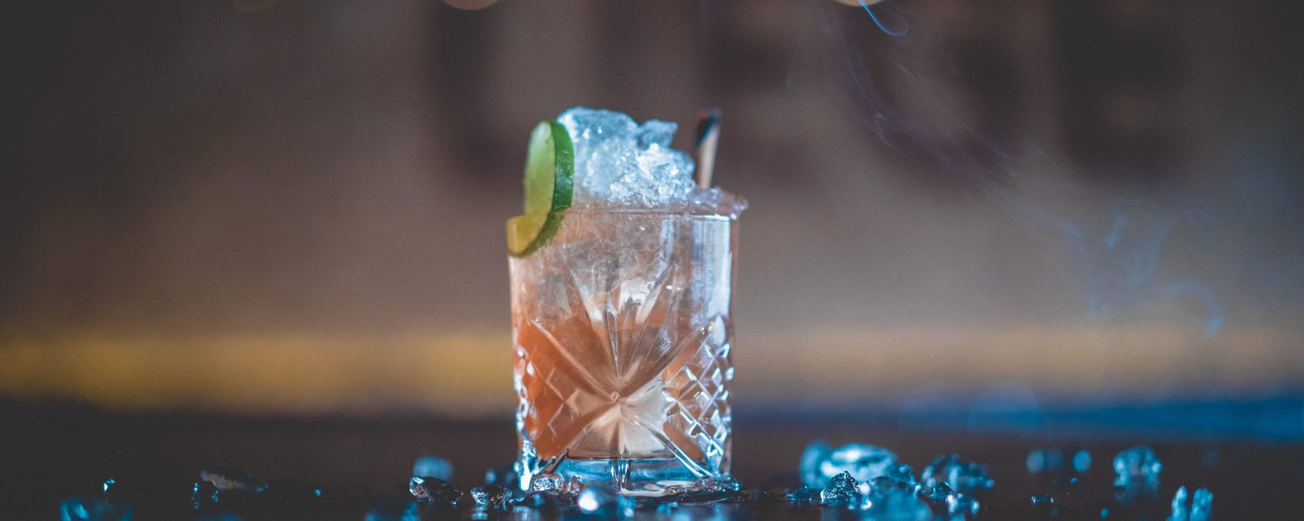

Name: received_315898639225880

* Clubs:
  + [Le Drague Cabaret Club – Drag show](https://ledrague.com/)
  + [Le Dagobert Night-Club](https://dagobert.ca/) $$
* Microbreweries
  + [Sacrilège Bar de Quartier](https://barlesacrilege.com/) $$
  + [Le Projet – Spécialité Microbrasseries](https://publeprojet.com/) $$
  + [Bateau de nuit](https://www.facebook.com/bateaudenuit/?_rdr) $
  + [Inox Brewery](https://brasserieinox.com/) $$
  + [Noctem - Artisans Brasseurs](https://www.noctem.ca/pages/libro) $$
  + [Korrigane – Brasserie Artisanale](https://www.korrigane.ca/en/) $$
  + [Griendel – Brasserie Artisanale](https://griendel.com/) $$
  + [La Souche Limoilou](https://www.lasouche.ca/) $$
  + [La Barberie](https://www.labarberie.com/en/?utm_source=quebec-cite.com&utm_medium=affiliate&utm_campaign=OTQ&utm_content=web) $$

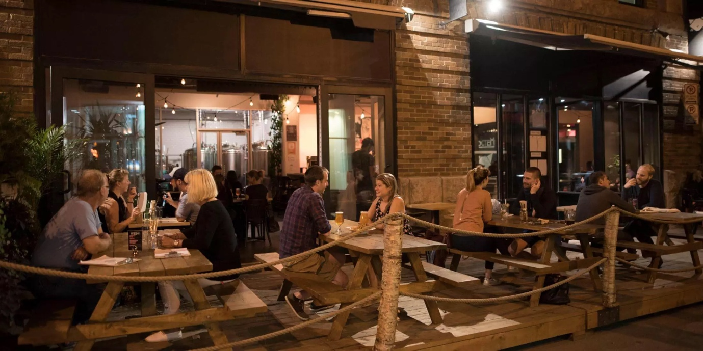

Name: Jeff Frenette Photography_2016_12SEPT_2066

* Cocktail bars
  + [Shaker Vieux-Québec](https://www.shakercuisineetmixologie.com/en/restaurants/st-joseph/) $$
  + [L’Atelier](https://bistrolatelier.com/en/home) $$$
  + [JJacques](https://jjacques.ca/#le-jjacques)
  + [Chez Tao!](https://cheztao.ca/) $$
  + [1608 Bar – Château Frontenac](https://www.fairmont.com/frontenac-quebec/dining/1608-bar/)
* Wine Bars
  + [Buvette Scott](https://www.facebook.com/buvettescott/) $$
  + [Le Renard et la Chouette](https://lerenardetlachouette.com/) $$

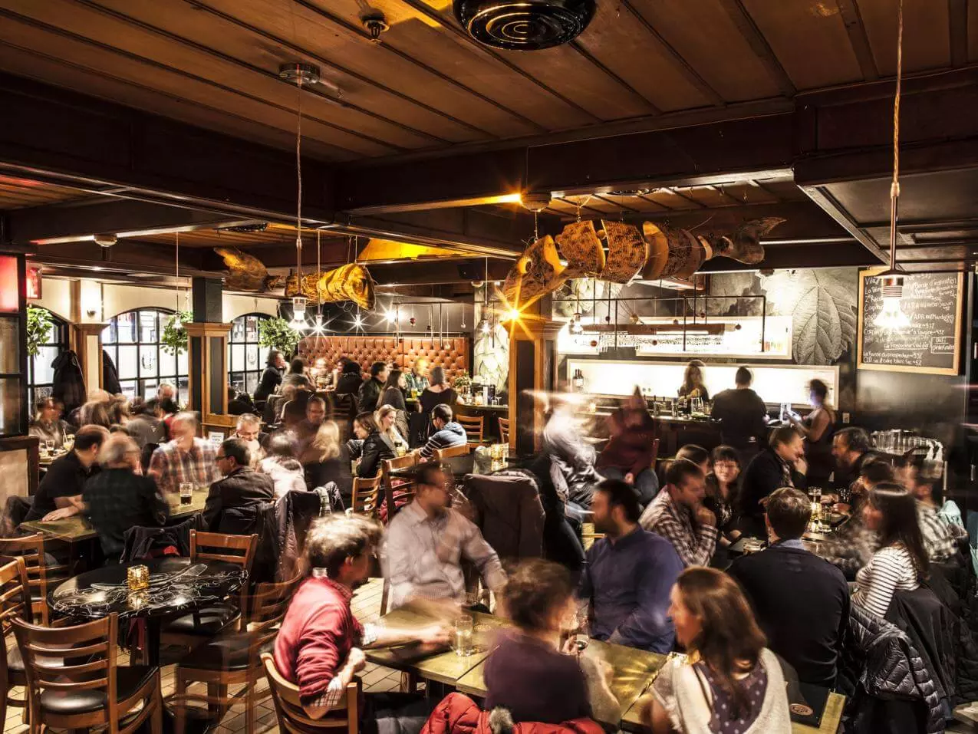

Name: _MG_5875_4305CD25-1B6E-4099-8F2C09741608A979_277583b0-c42b-4905-ba8b7638ea3d8335

* Other bars
  + [MacFly Bar Arcade](https://www.macflybararcade.com/?lang=en) $$
  + [La Revanche](https://boutique.larevanche.ca/en/service/reservez-une-table-a-la-revanche/)
  + [La cours arrière du Festibière](https://infofestibiere.com/la-cour-arriere-quebec-ang/?lang=en) $$
  + [Deux22](https://deux22.com/pages/ladn) $$

**Around Quebec City:**

Did you know that a few miles from downtown Quebec City (about 30 minutes away) is the region’s largest playground? Lovers of sport, nature, gastronomy, or relaxation, you will certainly find what you are looking for.

1 picture banner:

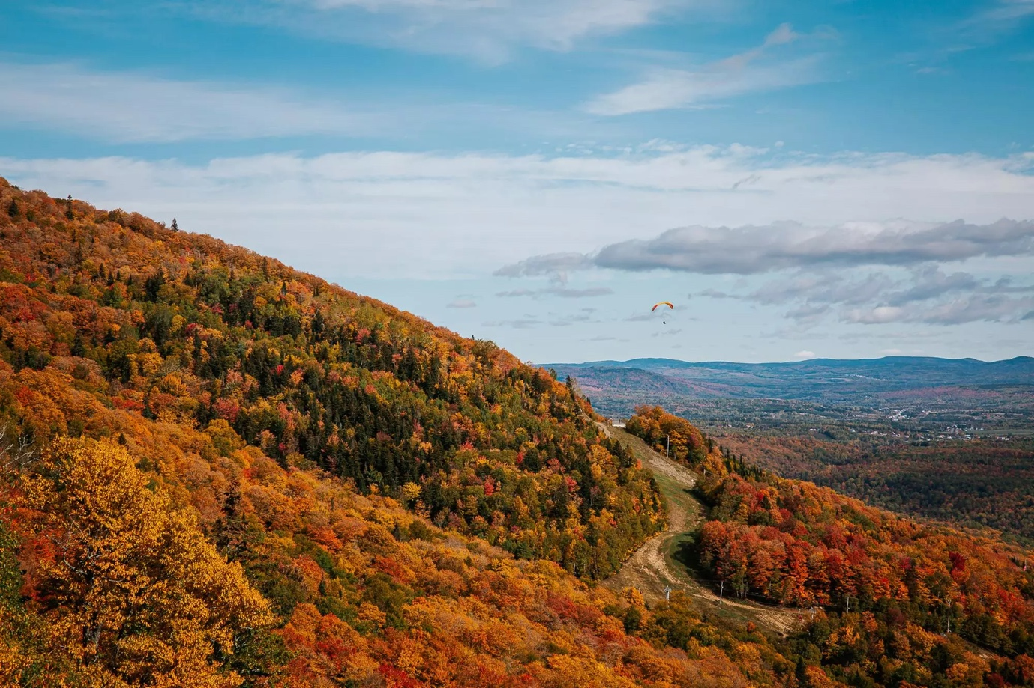

Name: web_automne_2019_otq_audetphoto-108

1. **Outdoor adventures**

* Rafting on the Jacques-Cartier River: Explore Quebec City area through white water rafting, a water sport that everyone can enjoy.
  + [New Wave Expeditions](https://expeditionsnouvellevague.com/en/)
  + [Équitation et Rafting Tewkesbury](https://excursionsjacquescartier.com/)

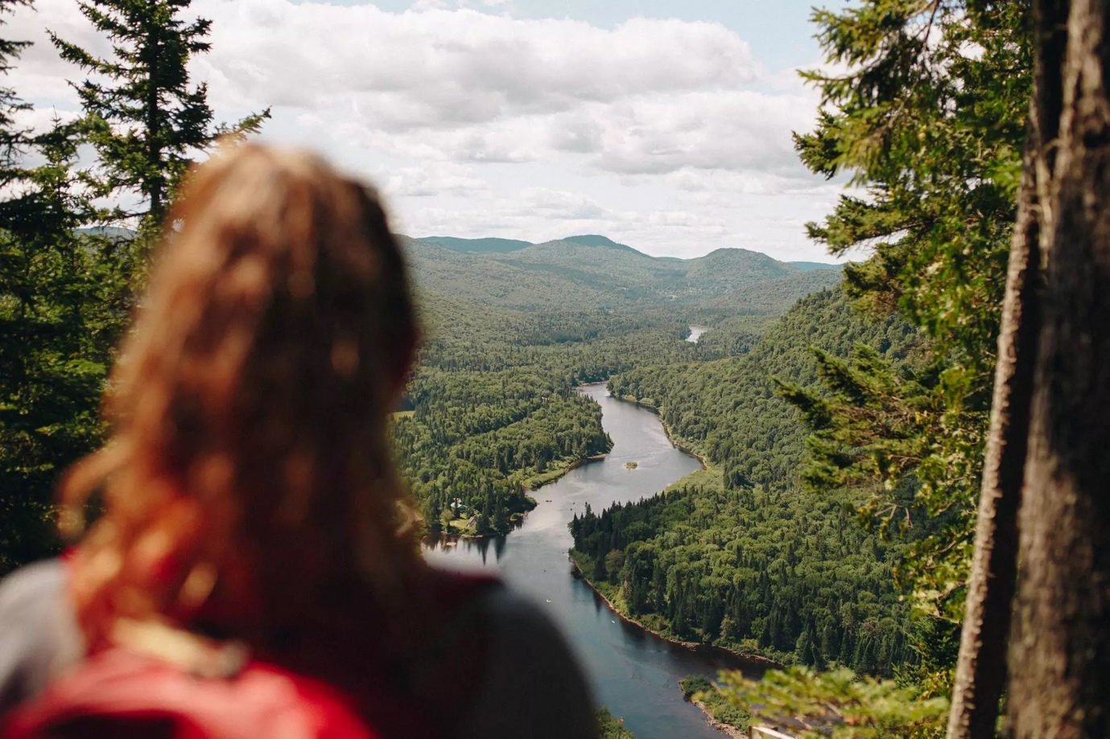

Name: Parc-national-de-la-Jacques-Cartier-@Xavier-Girard.web_

* Hiking & Walking:
  + [Jacques-Cartier National Park](https://www.sepaq.com/pq/jac/index.dot?language_id=1)
  + [Les Marais du Nord](https://maraisdunord.com/)
  + [Stoneham Station Loop](https://ski-stoneham.com/en/hiking/)
  + [Duchesnay Station](https://ulavaldti.sharepoint.com/sites/SPCP-2022-Comit-Activitssocialesettudiantes/Documents%20partages/Comité%20-%20Activités%20sociales%20et%20étudiantes/o%09https:/www.sepaq.com/ct/duc/index.dot)
  + [Trails and suspension bridges at Canyon Sainte-Anne](https://canyonsa.qc.ca/en/)
  + [Parc naturel régional de Portneuf](https://parcportneuf.com/)
  + [Île d’Orléans](https://tourisme.iledorleans.com/en/)
  + [Vallée du bars du Nord](https://www.valleebrasdunord.com/hiking-english)

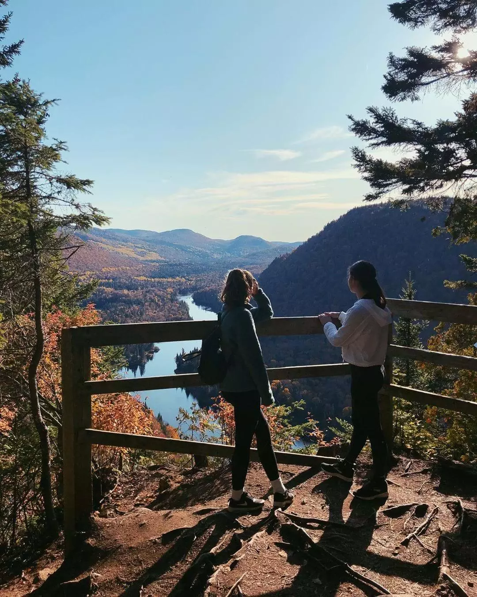

Name : evemaa-instagram-666-ig-2152750663040537802

* Mountain Biking (rental possible)
  + Empire 47: <https://www.empire47.com/activites-a-pratiquer-ete/>
  + Sentiers du Moulin: <https://www.sentiersdumoulin.com/>
  + Vallée du bars du Nord: <https://www.valleebrasdunord.com/mountain-bike-trails-Quebec>
  + Mont Saint-Anne: <https://mont-sainte-anne.com/en/interactive-trail-map/>
* Village Vacances Valcartier – Outdoor and Indoor Water Parc: <https://www.valcartier.com/en/activities/outdoor-waterpark/>
* Golfing (<https://www.quebec-cite.com/en/what-to-do-quebec-city/golf>)
  + Stoneham Golf Club : <https://golfstoneham.com/>
  + Mont Tourbillon : <https://monttourbillon.com/>
  + Centre Castor Golf: <https://www.cafconnection.ca/Valcartier/Facilities/Castor-Centre/Golf.aspx>
  + Le Grand Vallon Golf Course : <https://legrandvallon.com/en/>
  + Club de Golf Royal Québec : <http://www.royalquebec.com/index.php/en/>
  + Golf La Tempête : <https://www.golflatempete.com/en/>
  + Le Grand Portneuf Golf Course : <https://www.legrandportneuf.com/?utm_source=quebec-cite.com&utm_medium=affiliate&utm_campaign=OTQ&utm_content=web>
  + Golf De La Faune : <https://golfdelafaune.com/en/2620-2/>
* Ziplining, Via Ferrata and Treetop Trekking
  + Abraska Duchesnay : <https://www.sepaq.com/quoi-faire/arbraska-duchesnay.dot?language_id=1>
  + Montmorency Falls Zipline and Via Ferrata: <https://www.sepaq.com/destinations/parc-chute-montmorency/quoi-faire/via-ferrata-tyrolienne.dot>
  + Canyonning Vallée Bras-du-Nord: <https://www.valleebrasdunord.com/canyoning-english>

Wellness activities

* Spas :
* Nordique spa Stoneham : <https://lenordique.com/en/>
* Siberia Spa: <https://siberiaspa.com/en/>